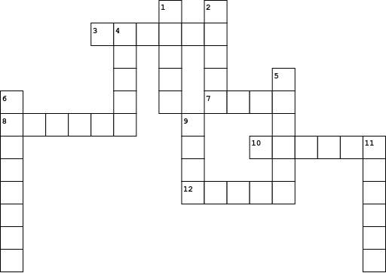

|  |  |  |  |  |  |
| --- | --- | --- | --- | --- | --- |
| **Across** | | Down | |  | Down |
|  | |  | |  |  |
| **3.** |  | **1.** |  | **9.** |  |
| **7.** |  | **2.** |  | **11.** |  |
| **8.** |  | **4.** |  |  |  |
| **10.** |  | **5.** |  |  |  |
| **12.** |  | **6.** |  |  |  |